Data Flow diagrams and Entity-Relationship diagrams are used to identify flow of data from one module to other.

Here is the design of both the diagrams for hospital management system.

|  |
| --- |
| Rahul maurya 20BCS7260 |

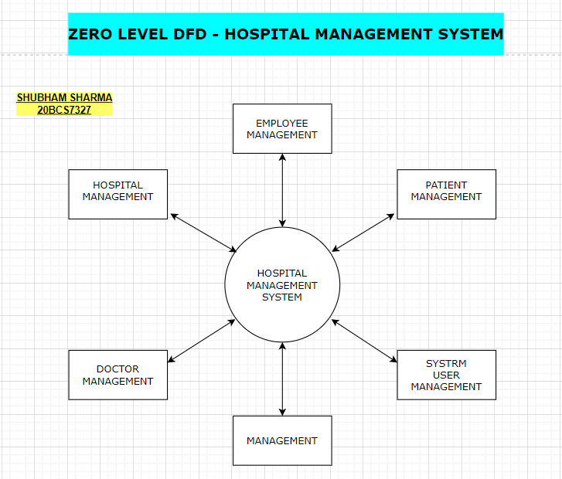

|  |
| --- |
| Rahul Maurya  20BCS7260 |

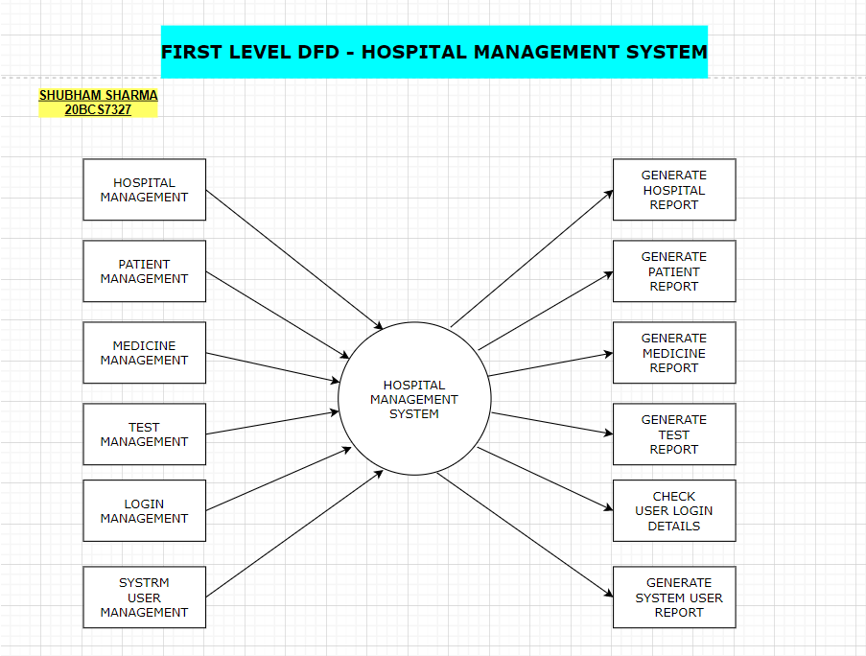

|  |
| --- |
| Rahul maurya  20BCS7260 |

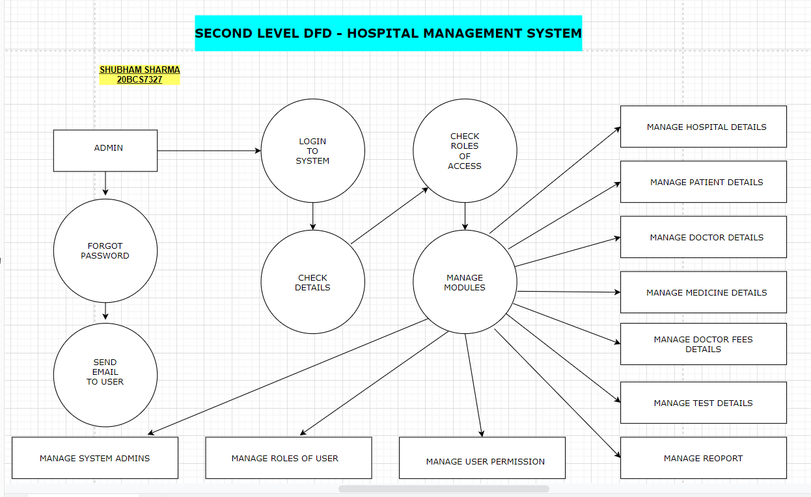

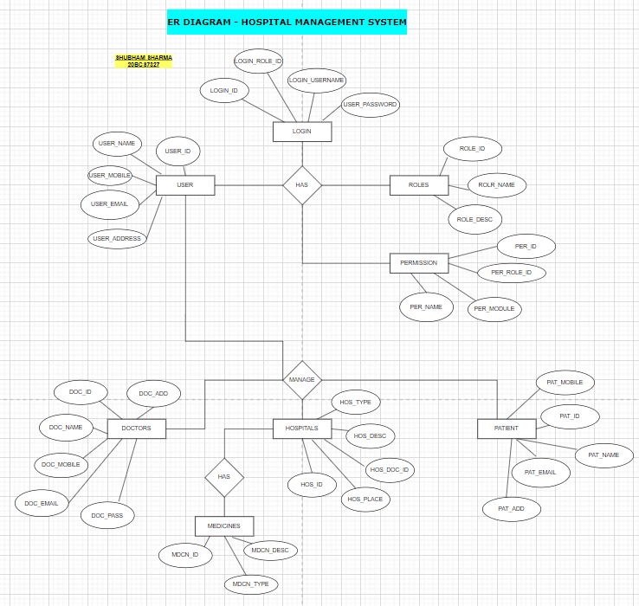

|  |  |
| --- | --- |
|  | Rahul maurya  20BCS7260 |